STATE OF MAINE
PUBLIC UTILITIES COMMISSION Docket No. 2010-235

August 29, 2012

MAINE PUBLIC UTILITIES COMMISSION REQUEST FOR COMMENTS
Long-Term Contracting for Offshore Wind (ON NON-CONFIDENTIAL
Energy and Tidal Energy Projects TERM SHEET)

WELCH, Chairman; LITTELL and VANNOY, Commissioners

I. SUMMARY

The Commission seeks comments on a term sheet filed pursuant to the Commission’s competitive solicitation for proposals for long-term contracts from deep-water offshore wind energy pilot projects or tidal energy demonstration projects.

II. BACKGROUND

During its 2010 session, the Maine Legislature enacted An Act to Implement the Recommendations of the Governor’s Ocean Energy Task Force (Act). P.L. 2009, ch. 615. Section A-6 of the Act directs the Commission, in accordance with the Maine Revised Statutes, Title35-A, section 3210-C, to conduct a competitive solicitation for proposals for long-term contracts to supply installed capacity and associated renewable energy and renewable energy credits from one or more deep-water offshore wind energy pilot projects or tidal energy demonstration projects.
As specified in the Act, the Commission may authorize one or more long-term contracts for an aggregate total of no more than 30 megawatts of installed capacity and associated renewable energy and RECs from deep-water offshore wind energy pilot projects or tidal energy demonstration projects as long as no more than 5 megawatts of the total is supplied by tidal energy demonstration projects. As required by the Act, the Commission initiated the competitive solicitation on September 1, 2010.
The Act specifies that the Commission may direct one or more transmission and distribution utilities to enter into a long-term contract only if it determines that the potential supplier:
A. Proposes sale of renewable energy produced by a deep-water offshore wind energy pilot project or a tidal energy demonstration project, referred to in this section as "the project;"

B. Has the technical and financial capacity to develop, construct, operate and, to the extent consistent with applicable federal law, decommission and remove the project in the manner provided by Title 38, section 480HH, subsection 3, paragraph G;

C. Has quantified the tangible economic benefits of the project to the State, including those regarding goods and services to be purchased and use of local suppliers, contractors and other professionals, during the proposed term of the contract;

D. Has experience relevant to tidal power or the offshore wind energy industry, as applicable, including, in the case of a deep-water offshore wind energy pilot project proposal, experience relevant to the construction and operation of floating wind turbines, and has the potential to construct a deep-water offshore wind energy project 100 megawatts or greater in capacity in the future to provide electric consumers in the State with project-generated power at reduced rates;

E. Has demonstrated a commitment to invest in manufacturing facilities in the State that are related to deep-water offshore wind energy or tidal energy, as applicable, including, but not limited to, component, turbine, blade, foundation or maintenance facilities; and

F. Has taken advantage of all federal support for the project, including subsidies, tax incentives and grants, and incorporated those resources into its bid price.
The Act also specifies that the Commission may not approve any long-term contract that would result in an increase in electric rates in any customer class that is greater than the amount of the assessment charged under Title 35-A, section 10110, subsection 4 at the time that the contract is entered (currently the assessment is $1.45 per MWh).
On August 15, 2012, Statoil North America, Inc. (Statoil) filed a proposed term sheet that would govern the terms for long-term contract with Maine utilities. The long-term contract would be with Maine’s three investor-owned utilities and have a term of twenty years. The pricing for the output of the facility and non-pricing terms are contained in the proposed term sheet. The term sheet is confidential as it contains proprietary information and is subject to Second Amended Protective Order No. 2 issued in this docket. Statoil also filed comments to the term sheet that are also confidential and subject to Second Amended Protective Order No. 2.

The Commission issued a Request for Comment on the confidential term sheet on August 15, 2012. That Request for Comment was issued to the parties authorized by Second Amended Protective Order No. 2 to receive confidential information in this docket. Comments on the confidential term sheet are due today, August 29, 2012 and are confidential documents subject to the terms of Second Amended Protective Order No. 2.

On August 29, 2012, Statoil filed a non-confidential redacted version of the term sheet and its comments which the Commission is circulating to the Service List in the above-referenced docket, to the Ocean Energy Task Force Members and to persons who requested to be notified of Ocean Energy Task Force events. The non-confidential version of the Statoil term sheet and Statoil’s comments will also be available on the Commission’s website in the very near future.

III. REQUEST FOR COMMENTS
The Commission requests comments on the standards and criteria the Commission should use in evaluating the term sheet, whether the proposed term sheet is consistent with the language of the Act and its purpose and intent, and whether the term sheet should be approved.
Please provide comments via email to Sarah Tracy (sarah.b.tracy@maine.gov) and Mitch Tannenbaum (Mitchell.tannenbaum@maine.gov) by 4 p.m. on Friday, September 7, 2012.

Dated at Hallowell, Maine, this 29th day of August, 2012.

BY ORDER OF THE PRESIDING OFFICER

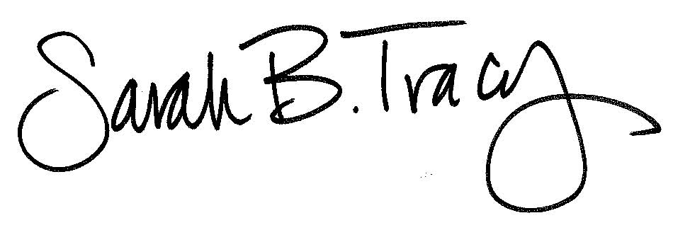

__________________________
Sarah B. Tracy

